Recognition of corresponding angles, alternate angles
and interior angles on the same side of the transversal

Key stage: 3
Dimension: Measures, Shape and Space
Learning Unit: Angles related with Lines and Rectilinear Figures
Basic Competency:
KS3-MS7-1: Students can demonstrate recognition of the following terminologies on angles with respect to their positions relative to lines and polygons:
(a) adjacent angles
(b) angles at a point
(c) vertically opposite angles
(d) interior angles and exterior angles of polygons
(e) angles associated with lines and their transversals

Learning target:
Students can distinguish among corresponding angles, alternate angles and interior angles on the same side of the transversal.

Teaching suggestions:
Session | Teaching sequence | Teaching materials
Introduction | - Introduce the definition of “transversal” with the powerpoint “Corr. angles, alt. angles, int. angles on same side”. Students are asked to observe the angles formed by two straight lines and their transversal.  - Introduce corresponding angles, alternate angles and interior angles on the same side of the transversal with the same powerpoint. Ask the students to notice about the location of each pair of angles and get known to the definition of each type of the angles mentioned above. | Powerpoint:  “Corr. angles, alt. angles, int. angles on same side”
Activity | Classification game:  - 4 students in a group. Each group has 4 word cards (corresponding angles, alternate angles, interior angles on the same side of the transversal and none of them) and a set of 16 picture cards with different types of angles. | Picture cards:  Different types of angles  Word cards:  Name of different type of angles
Session | Teaching sequence | Teaching materials
- Students in each group aim to classify 16 pairs of angles into 4 categories shown in the word cards. Students can divide their work on their own, such as classifying cards, checking, preparing for a presentation etc.
- 4 groups of students are chosen for reporting their results, with each group reporting one category of angles. Students should also explain their classifying rules.
For example,
“For these pairs of angles, each pair of angles is located on the same side of the transversal, and also on the same side of the two straight lines. It fits with the definition of corresponding angles, so they are pairs of corresponding angles.”
The presentation sheet on page 7 can be shown during the time of presentation. Students can show their results by dragging the pairs of angles into the appropriate boxes for a clear explanation.
- As for the angles in the category of “none of them”, students should explain from their observation on the positions of the angles.
* Teachers can decide in what ways the students report.
Consolidation | Students complete the worksheet “Distinguish among corr. angles, alt. angles and int. angles on same side”, then check the answers with the teacher. | Worksheet:  “Distinguish among corr. angles, alt. angles and int. angles on same side”
Session | Teaching sequence | Teaching materials
Conclusion | When two straight lines are cut by their transversal, different types of angles will be formed. These angles will be named differently according to their relative positions. Here we have corresponding angles, alternate angles and interior angles on the same side of the transversal.  Definition:  - Corresponding angles: a pair of angles located on the same side of the transversal and also on the same side of the two straight lines.  - Alternate angles: a pair of angles located on the opposite sides of the transversal and lie between the two straight lines.  - Interior angles on the same side of the transversal: a pair of angles located on the same side of the transversal and lie between the two straight lines.

Picture cards: different types of angles
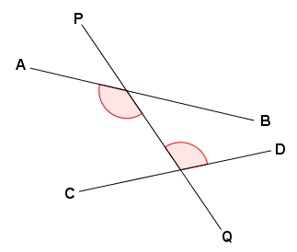  Fig. 1 | 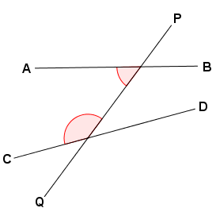  Fig. 2
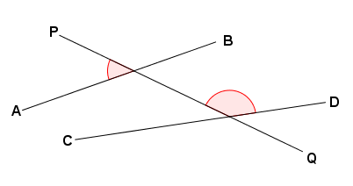  Fig. 3 | 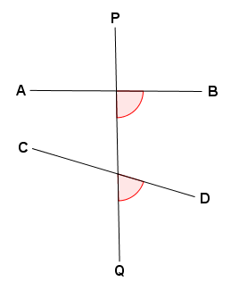  Fig. 4
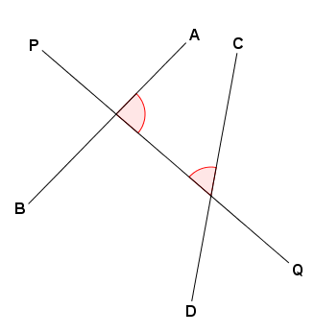 | 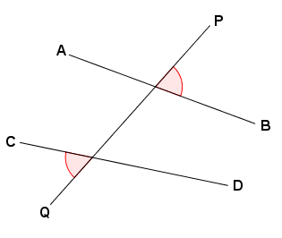  Fig. 6  Fig. 5
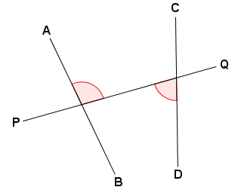 | 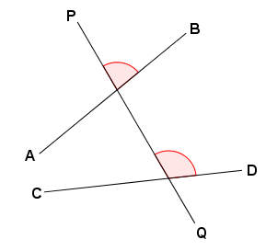  Fig. 8  Fig. 7
Picture cards: different types of angles
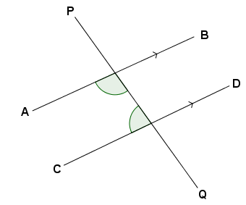  Fig. 9 | 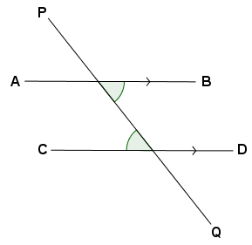  Fig. 10
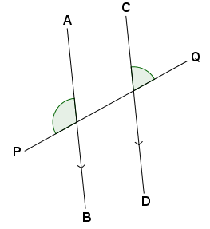  Fig. 11  Fig. 12 | 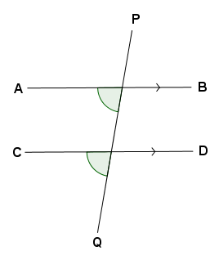
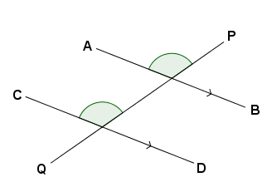  Fig. 14  Fig. 13 | 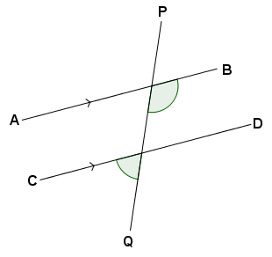
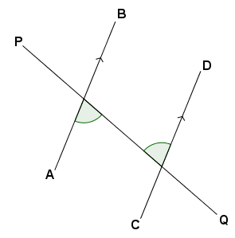  Fig. 15 | 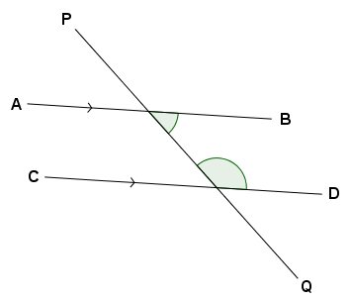  Fig. 16

Word Cards

Corresponding Angles | Alternate Angles
Interior Angles  on the same side of  the transversal | None of them

Corresponding Angles | Alternate Angles | Interior Angles  on the same side of the transversal | None of them
Presentation Sheet
Students can drag the figures below to the appropriate categories of angles.

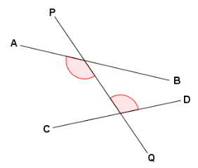  Fig. 1 | 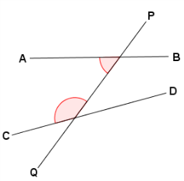  Fig 2 | 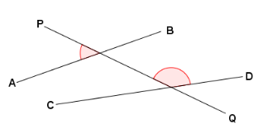  Fig. 3 | 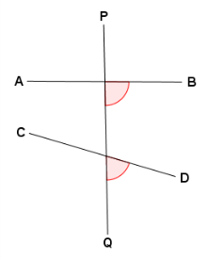  Fig. 4 | 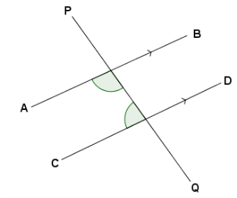  Fig. 9 | 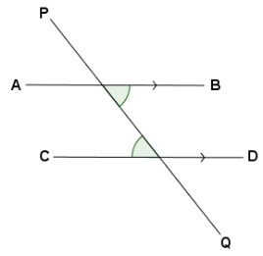  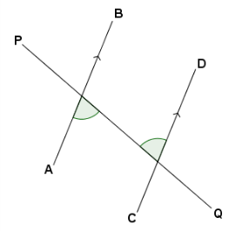  Fig. 10  Fig. 15 | Fig. 11 | 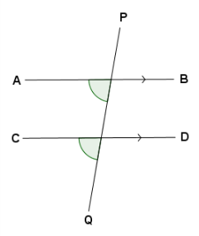  Fig. 12
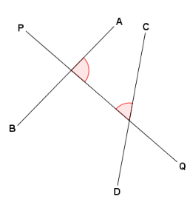  Fig. 5 | 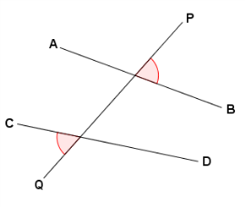  Fig. 6 | Fig. 7 | 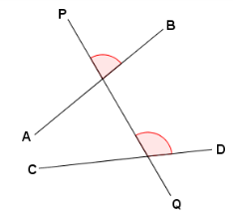  Fig. 8 | 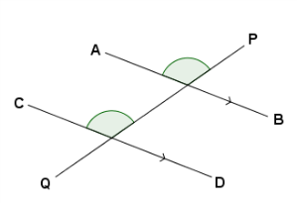  Fig. 13 | 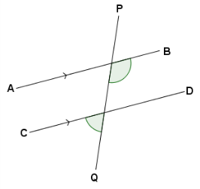  Fig. 14 |  | 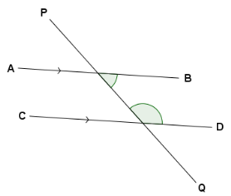  Fig. 16
Answer

Corresponding Angles  Fig. 4  Fig. 8  Fig. 12  Fig. 13 | Alternate Angles  Fig. 7  Fig. 10  Fig. 15 | Interior Angles  on the same side of the transversal  Fig. 16  Fig. 9  Fig. 5  Fig. 2 | None of them  Fig. 1  Fig. 3  Fig. 6  Fig. 14  Fig. 11

